1. **Where does the problem come from?**

Based on zoom meeting last week, a further check for vertical stress as well as pore pressure according to figure 1 was required, since the vertical stresses have similar manner between 2D and 3D, while pore pressure displays different tendency. In addition, a huge oscillation of pore pressure at “L=8 in” is noticed in figure 1b, an explanation is needed.

|  |  |  |
| --- | --- | --- |
| Base Top |  |  |
|  | (a) Vertical stress | (b) Pore pressure |

**Fig.1** Dynamic responses of vertical stress and pore pressure (copied from the report: 3. Comparison between PEFIT 2D plane strain and 3D axisymmetric cases 07112020, figures 3a1 and 3a2)

1. **Objectives**
2. Pore pressure formula in 2D plane strain
3. A further check for stress is performed by displaying the Von Mises stress and hydrostatic stress
4. Analyzing of Source that causes oscillation of pore pressure is analyzed
5. **Stresses under plane strain assumption**

The constitutive relationships for the poroelastic medium are expressed as:

(1) (2)

Under plane strain assumption () it can be expressed as:

(3)

(4)

(5)

(6)

(7)

Where , denotes the displacement of pore water in z direction.

1. **Plot of Von Mises stress and hydrostatic stress**

***4.1 Von Mises Equations***

 (8)

In plane strain case, the stresses are list as:

(9)

Note: for derivation of , please refer to Appendix 3.

***4.2 Hydrostatic stress***

(10)

***4.3 Plots of stress***

In 2D case, **load length 4 in.** in figure 1a is chosen since the vertical stress of both 2D and 3D results are closest to each other.

In the plots below:

|  |  |
| --- | --- |
|  | [Von Mises stress]  3D case is axisymmetric while 2D is NOT, also for 2D when load is far away from measuring point, the stress is not close to zero. |
|  |  |
| (b) | [hydrostatic stress]  Both 2D and 3D have the similar tendency. |
|  |  |
| (c) | [vertical stress]  For vertical stress 2D and 3D have similar manner and similar value.  If only -200 to -20 is compared, oscillation can be found at the beginning of 2D case. |
|  |  |
| (d) | [horizontal stress]  Both 2D and 3D are symmetric (3D is not really symmetric at center, also I expect horizontal stress anti-symmetric), but they do NOT have similar behavior. |
|  |  |
| (e) | Both 2D and 3D are symmetric, they have similar tendency but different value. |
|  |  |
| (g) | [shear stress]  For shear stress 2D and 3D have similar manner and similar value. |
|  |  |
| (h) | [Pore pressure]   1. 2D pore pressure has huge oscillation at beginning 2. 2D and 3D pore pressure have different pore pressure behavior of peaks |

**Fig.2** plots of stress

**Updated by 09262020**

1. **Analyzing of oscillation – impacts of initial loading position/width of model**

The effect of 1) distance between initial loading position and measuring point 2) width of model are tested.

1. Fig. 3a is a partial magnified plot of figure 1b, where pore pressure responses have similar behavior under different loading length (I was asked during last meeting).
2. Huge oscillation in Fig 3a is observed when loading length is 8 in., such case is picked and testes, where Figure 1b presents the effect of the distance of initial loading position to measuring point. To analyze, different distances are chosen (200 in., 250 in., 300 in., 350 in.).

* Farther distance decreases magnitude of negative pore pressure at beginning.
* Farther distance increases the magnitude of positive pore pressure.
* Though different distance causes different oscillation of dynamic pore pressure at the beginning, **but all four curves (red, black, blue and green) have the same peaks and behavior.**

1. In Figure 3b, the width of model is 800 inches, to further test the width effect, a 1400-inches-width model is calculated, and different distances (100 in., 200 in., 300 in., 400 in.) are tested, from the plot, except the 100 in. result have minor difference at the middle peak point, no other differences are noticed at the peaks under each scenarios, again different oscillation of pore pressure at initial is observed.

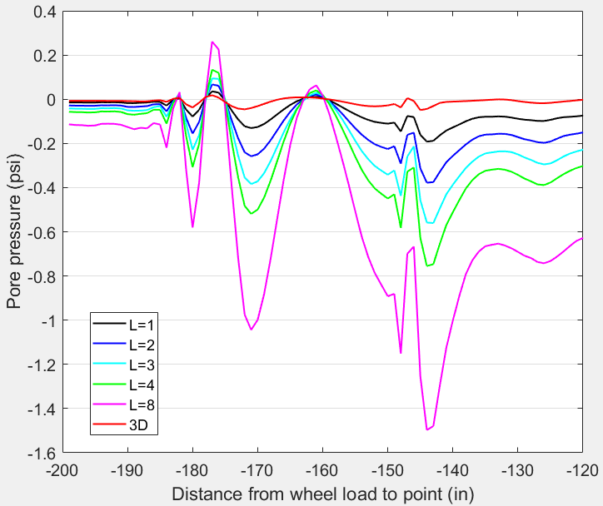

1. Initial pore pressure under different loading length

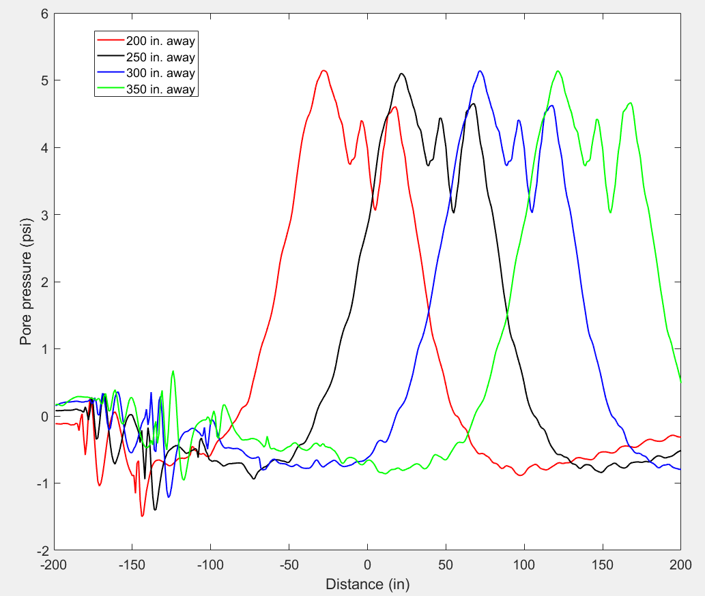

1. different initial position to measuring point (L=8 in.) model 800 in wide

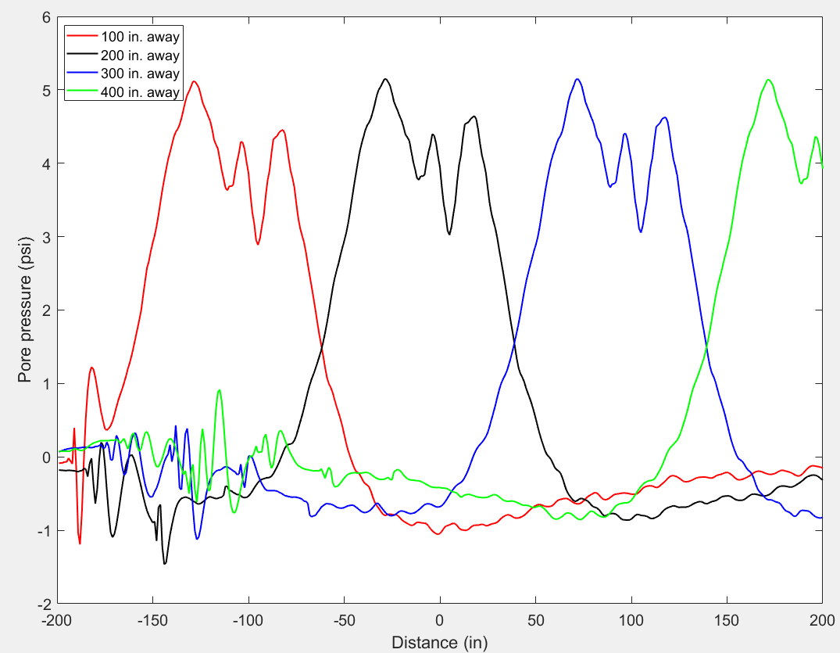

1. different initial position to measuring point (L=8 in.) model 800 in wide

Fig. 3 Pore pressure responses

**Partial conclusion:**

* The distance between initial loading position and measuring point does not affect the peak points of pore pressure.
* The width of the model size does not affect the peak points of pore pressure.
* Different formats of initial oscillation of pore pressure seem do not affect the peaks value.

1. **Analyzing of oscillation – initial loading position; width of model**

In figure 4, different landing time (100,300,600,900-time intervals) as well as hard landing case are tested. From plots, pore pressure (figures 4a and b) and vertical stress (figures 4c and d) do not change with soft-landing time much, the curves have very similar manner and value. **Especially, the initial oscillation still exists and does not change with soft-landing time,** it is possible that the oscillation exists due to the moving tire pressure.

|  |  |
| --- | --- |
|  |  |
| 1. pore pressure | 1. pore pressure initial |
|  |  |
|  |  |
| 1. vertical stress | 1. vertical stress initial |

Fig. 4 Pore pressure and vertical stress

**Partial conclusion:**

* Soft-landing time do not affect the initial oscillation of pore pressure and has very limited impact on overall behavior and peaks of pore pressure.

**Updated by 09272020**

1. **Analyzing of oscillation – initial loading position; width of model**

To calculate the soft-landing effect on initial oscillation of pore pressure, loading condition in figure 5d is tested. Just for reference, figure 5a and 5b denotes for the mechanism of hard landing and soft landing are shown, and figure 5c is the hard landing condition.

|  |  |
| --- | --- |
|  |  |
| 1. hard landing | 1. soft landing |
|  |  |
|  |  |
| 1. Landing effect of hard landing | 1. Landing effect soft landing – 100 delay |

Fig. 5 Loading condition

Note: T= one-time interval; One-time interval= 1000 * dt; dt= 1E-06;

Two methods (Figure 6) are tried to calculate the soft-landing effect in figure 5d. In figure 6a soft landing is same as figure 5d, method 2 is a combination of loading conditions to achieve the same effect. The dynamic responses from two methods Figure 6 b and d are exactly the same as expected. A huge oscillation is observed at the beginning.

The dynamic responses of pore pressure from two loading conditions in figure 6c are presented in figures 7c and d respectively. Figure 7d reveals that the huge oscillation in figure 6b/6d is due to the pulse loading effect. Similarly, in figure 6a, due to the suddenly dropped load to zero at 101T, numerical oscillation happens in initial pore pressure. **Therefore, loading condition in figure 5d is not suitable for measuring soft-landing effect on pore pressure development.**

|  |  |  |
| --- | --- | --- |
| Method # |  |  |
| 1 |  |  |
|  | 1. soft landing method 1 | 1. dynamic response of pore pressure |
| 2 |  |  |
|  | (c) soft landing method 2 | (d) dynamic response of pore pressure |

Fig. 6 Loading condition and dynamic pore pressure

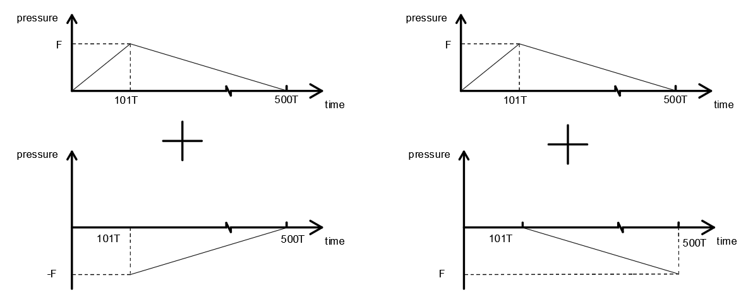 

(a) (b)

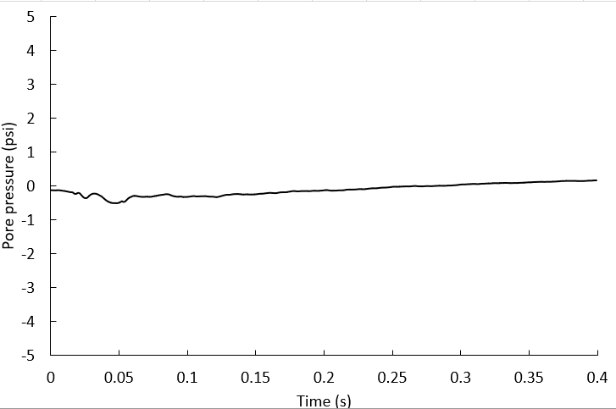 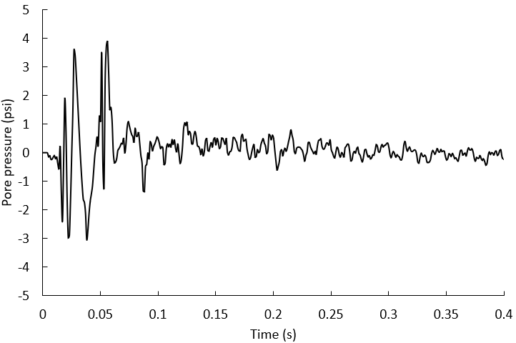

(c) (d)

Fig. 7 loading condition of figure 6c and its dynamic responses respectively

1. **Conclusions.**
2. The **distance between initial loading position and measuring point** / **the width of the model size** / **soft-landing time** does not affect the peak points of pore pressure.
3. Initial oscillation of pore pressure have little impact on the peak points and the overall pore pressure development.
4. The attempt to measure soft landing effect failed due to the numerical oscillation.

Things are unclear:

What is the cause of initial oscillation of pore pressure development?

**Appendix**

1. **Elastic theory for plane strain**

Constitutive equation:

(1)

Equilibrium equation:

(2)

Plane strain is applied in the 2D study,

Under the assumption, the displacement components are given:

=(𝑥, 𝑦, 𝑡); =(𝑥, 𝑦, 𝑡); = 0;

The above relations suggest the following:

**=𝑥, 𝑦, 𝑡); =𝑥, 𝑦, 𝑡); =(𝑥,𝑦,𝑡);**

**;**

therefore, the constitutive equations can be simplified by setting ,,.

0

0

0

where is strain tensors; ; is the Kronecker delta ( for and for )

2D plain strain constitutive equation is expanded as:

(1.1)

(1.2)

(1.3)

(1.4)

(1.5)

(1.6)

Equilibrium equation is expanded as:

(2.1)

(2.2)

1. **Poroelastic theory**

***2.1 Governing equation of Biot’s theory***

The general governing equations are expressed as below.

2.1.1 The equilibrium equation is expressed as

(3)

where is the total stress in bulk medium;

is the relative displacement vector of pore water to that of solid.

2.1.2 The constitutive relationships for the poroelastic medium are described

(4)

(5)

where is strain tensors; ; is the Kronecker delta ( for and for )

2.1.3 Dynamic Darcy’s law

(6)

***2.2 Plane Strain***

2.2.1 Under the assumption, the displacement components are given:

= (𝑥,𝑦,𝑡) ; = (𝑥,𝑦,𝑡) ; =0;

; ; ; (7)

Where:

U denotes for the vector fluid displacement vector;

u denotes for the solid frame displacement vector.

The above relations suggest the following:

= (𝑥,𝑦,𝑡); = (𝑥,𝑦,𝑡); = (𝑥,𝑦,𝑡);

; (8)

;;;

(9)

(10)

Where: denotes for flux, means it is impermeable in z direction.

; n is porosity. (11)

.(12)

For stress, it can easily be derived that:

(13)

2.2.2 the G.E. (1-4) under plane strain assumption can be expanded accordingly.

2.2.2.1 The equilibrium equation is expanded.

(14)

2.2.2.2 The constitutive relationships for the poroelastic medium are expanded.

(15)

(16)

2.2.2.3 Dynamic Darcy’s law is expanded.

(17)

***2.3 Plane Stress***

2.3.1 Under the assumption of plane stress, normal stress and shear stresses in z direction are assumed to be zero. However, pore pressure as a pressure acts in x, y, z dimension quantitative equality, it is essentially a scalar, if pore pressure is assumed zero in z direction, it can be understood as zero pressure in a porous medium, thus it is recognized that plane stress is not applicable in poroelastic analysis.

However, if only solid frame is assumed as plane stress.

; (18)

Where

is effective force, which is the force taken by solid frame only;

is the total force.

The above relations suggest the following:

; (19)

2.3.2 the G.E. (1-4) under plane strain assumption can be expanded accordingly.

2.3.2.1 The equilibrium equation is expanded.

(20)

2.3.2.2 The constitutive relationships for the poroelastic medium are expanded.

(21)

(22)

2.3.2.3 Dynamic Darcy’s law is expanded.

(23)

1. **Derivation of Von Mises stress (2D plane strain)**

For each step two purple parameters are known, and the red parameter is unknown.

Therefore,

1. **Derivation of Von Mises stress (3D plane strain)**

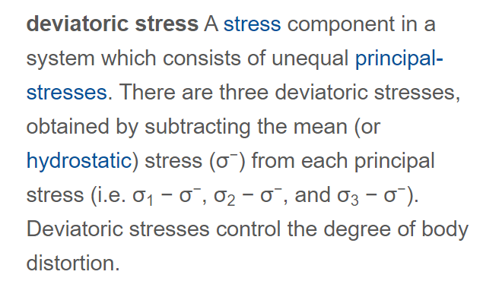

<https://www.encyclopedia.com/science/dictionaries-thesauruses-pictures-and-press-releases/deviatoric-stress#:~:text=deviatoric%20stress%20A%20stress%20component,%CF%83%203%20%E2%88%92%20%CF%83%20%E2%88%92>).

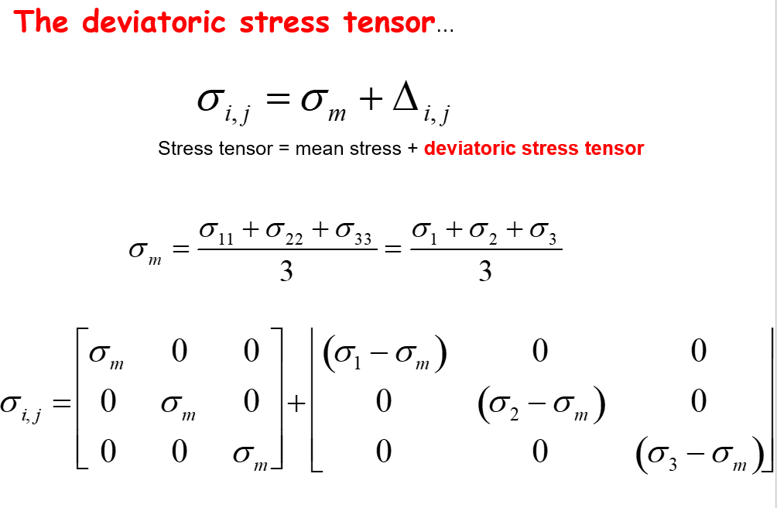

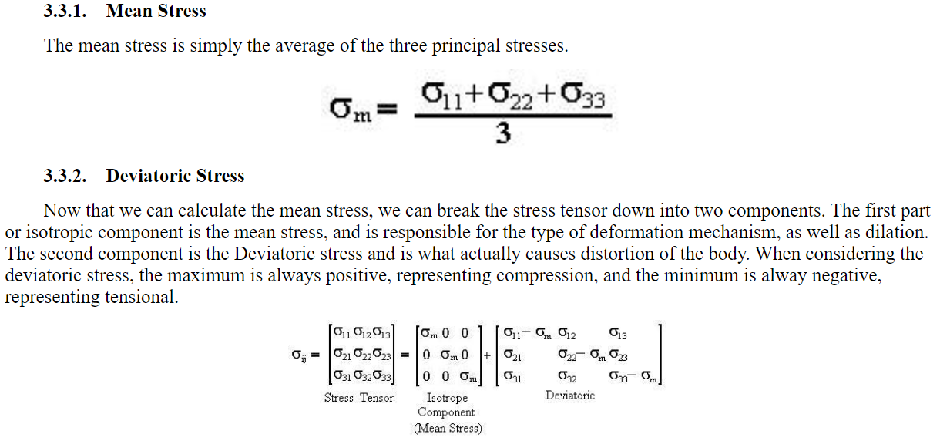

**http://www.geosci.usyd.edu.au/users/prey/Teaching/Geol-3101/Strain/stress.html**